# Department of Computing

**EC-303: Mobile Application Development Class: BESE 11AB**

## Lab 06: Navigation, Passing information, Alert Dialog and State Management

**CLO 2: Use advanced design and development techniques for developing data-driven Mobile Interfaces**

**Date: 12-Mar-2024**

**Time: 09:45 AM - 11:55 AM**

**Name: Ali Raza Dar**

**CMS: 343375**

**Instructor: Ms. Naema Asif  
 Lab Engineer: Mr. Aftab Farooq**

**Lab 6: Navigation, Passing information and Alert Dialog, State Management**

**Objectives**

This lab will get students familiar with some advanced concepts in Material Design, Navigation and adding interactivity to the app and State Management.

**Topics to be Covered**

* Adding Interactivity using Alert Dialog
* Adding Navigation to your Flutter App
* State Management

**Tools/Software Requirement**

* Flutter SDK
* Android Studio
* VS Code
* [FlutLab](https://flutlab.io/)

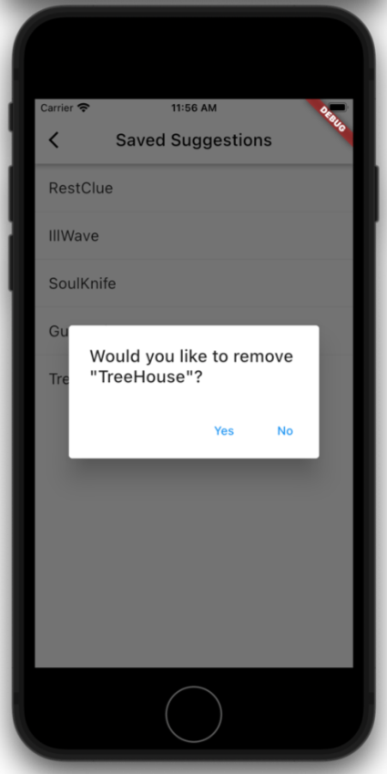**Lab Tasks**

**Task # 1**

This task requires you use to the codebase from [Helping Codebase Link](https://codelabs.developers.google.com/codelabs/first-flutter-app-pt2) and modify the codebase to meet the requirements given below.

The skeleton code for this lab can also be downloaded from [GitHub.](https://github.com/flutter/codelabs/tree/master/namer/step_08)

* + Modify the code in “Saved Suggestions” screen to show a confirmation dialog when user taps any item from the list
  + Tapping the “Yes” button should:
    - Remove the selected item from the “Saved Suggestions” list
    - Dismiss the dialog
    - Take user back to the previous screen
    - Also make sure that state of removed item is also set to “unselected” in the “Startup Name Generator” List
  + Tapping the “No” button should just dismiss the dialog
  + Tapping outside the ***AlertDialog*** should not dismiss the dialog

## Task 1: Deliverables

Zip the fully working source code and upload it on LMS

|  |
| --- |
| ScreenShots Task1: |

## Task # 2

This task requires you use to the codebase from [Helping Codebase Link](https://codelabs.developers.google.com/codelabs/first-flutter-app-pt2) and modify the codebase to meet the requirements given below.

The skeleton code for this lab can also be downloaded from [GitHub.](https://github.com/flutter/codelabs/tree/master/namer/step_08)

* + Modify the code in “Saved Suggestions” screen to meet following requirements
  + User should be able to select / deselect an item from the list
  + “Selected” item should have a checkmark icon on the right side (screenshot 1)
  + Tapping a “selected” item should deselect it and remove the checkmark (and vice versa)
  + User should be able to tap the “Delete” button from AppBar to see a confirmation dialog to delete the “selected” items from the list (screenshot 2)
  + Tapping the “Yes” button should:
    - Remove the selected items from the “Saved Suggestions” list
    - Dismiss the dialog
    - Take user back to the previous screen
    - Also make sure that state of removed items is also set to “unselected” in the “Startup Name Generator” List
  + Tapping the “No” button should just dismiss the dialog
  + Tapping outside the ***AlertDialog*** should not dismiss the dialog
  + The ***AlertDialog*** should only be visible when at least one item is selected from the list
  + In case the User taps the “Delete’ button without selecting an item from the list, he should see a

***SnackBar*** at the bottom of the screen with the message “No Item Selected” (screenshot 3)

|  |  |  |
| --- | --- | --- |
|   *Screenshot 1: Selected/unselected items* |   *Screenshot 2: AlertDial* |   *Screenshot 3: Snackbar* |



## Task 2: Deliverables

Zip the fully working source code and upload it on LMS

|  |
| --- |
| **Task 2 Screenshots**     |